FACULTY EVALUATION FORM
Drexel University
Faculty members will be given an overall performance evaluation based on the individual’s teaching, research/scholarship/creative activity, and service activities. The status of the goals set for the previous evaluation period will be reviewed, and new goals will be established for the next evaluation period. Long term goals with milestones are encouraged.

Name: Cyndi Rickards Date of Evaluation: 4/18/14

Dept./Prog: Culture & Communication/CJ Dept. Head/Prog. Director: Wesley Shumar/Robert
Kane

SERVICE

Highlights and Activities:

Professor Rickards has continued in her role as the COAS Community Outreach Coordinator. At the university level she remains active with the Dornsife Center as a member of their Advisory Board, and Executive Future Search Committee. Professor Rickards was also on the University Assessment Committee, as well as the Public School Reform Committee. In the Department, Professor Rickards worked as the ePortfolio Coordinator and the CJ Recruitment Coordinator. In the latter role, she led the organization of an Eastern State Penitentiary recruitment event, as well as called 75 accepted students.

In addition to her Drexel service work, Professor Rickards also serves on the Inside-Out International Prison Exchange Program Steering Committee, as well as the LIFT Advisory Board.

Status of Prior Year Goals:

Service Performance Evaluation:

X 5 - Outstanding o 4 o 3 o 2 o 1 - Unsatisfactory

Goals for this year:

Professor Rickards will continue with her regular service load.

INSTRUCTION

Part I (Courses Taught):

Spring 2012-13: Soc 115 - Social Problems

Fall 2013-14: Univ H101

Winter 2013-14: CJ380 - Justice in our Community (CBL course)
CJ206 - Criminal Justice
Spring 2012-13

Course Prefix | Course Number & Section Number | Course Title | Credit Hours | Meeting Days & Times | # of Graded Students
SOC | 115-900 | Social Problems | 3 | Online | 14

Summer 2012-13

Course Prefix | Course Number & Section Number | Course Title | Credit Hours | Meeting Days & Times | # of Graded Students

Fall 2013-14

Course Prefix | Course Number & Section Number | Course Title | Credit Hours | Meeting Days & Times | # of Graded Students
UNIV | H101-003 | The Drexel Experience | 1 | T 100-150 | 11

Winter 2013-14

Course Prefix | Course Number & Section Number | Course Title | Credit Hours | Meeting Days & Times | # of Graded Students
CJ | 380-002 | ST: Justice in Our Community | 3 | TR 1100-1220 | 13
CJ | 206-900 | Criminal Justice | 3 | Online | 15

INSTRUCTION

Part II (Commentary):

Highlights and Activities:

Professor Rickards taught a 2-1-1- load. She developed two new Community-Based Learning courses and taught one of them during the current evaluation period. She also redeveloped our University 101 course so that it served as a platform to integrate the new iPad program into the curriculum. Finally, she was nominated for the President's Civic Engagement Award for the outstanding work she does with several local community service institutions.

I evaluated two of her courses.

In CJ 206, for the question would students strongly agreed they would recommend the course to another student, the professor had a mean score of 4.67 out of 5. In the same course, for the question would students recommend the professor, she had a mean score of 4.33 out of 5. Finally, for the question of whether the students rated the professor as excellent, he had a mean score of 2.67 out of 3. While these are excellent scores, with a higher response rate (where single responses would be weighted less), I would expect the scores to increase dramatically.

In CJ380 - Justice in our Community (our first required CBL course), for the question would students strongly agreed they would recommend the course to another student, the professor had a mean score of 4.00 out of 5. In the same course, for the question would students recommend the professor, she had a mean score of 3.5 out of 5. Finally, for the question of whether the students rated the professor as excellent, she had a mean score of 2.5 out of 3. Given that just four students are included in this course evaluation, I am not sure the results tell us anything reliable about the professor or the course.

In addition to evaluating Prof. Rickards’ teaching evaluations, I also reviewed her course syllabi, noting that she incorporates many innovative pedagogical techniques into her classwork. These innovations take substantial time to learn and apply; and I can only presume they greatly enhance her teaching effectiveness. I must also reiterate the substantial time it has taken Prof. Rickards to develop the iPad program and the e-portfolio framework for use among our current first-year students.

Status of Prior Year Goals:

Instructional Performance Evaluation:

X 5 - Outstanding o 4 o 3 o 2 o 1 - Unsatisfactory

Goals for this year:

Professor Rickards plans to develop (and redevelop) two courses - one will be another CBL called "Beyond the Code of the Street,” and our second University 101 course. In addition, she will continue to work with students on their e-portfolios.

RESEARCH, SCHOLARSHIP AND CREATIVE ACTIVITY

Highlights and Activities:

Professor Rickards is not evaluated for her research. Still, I note that she was co-author of a paper that was accepted for publication by the Michigan Journal of Community Service Learning; and she presented papers at three education conferences, one of which in Barcelona. Professor Rickards continues in her Doctoral Program in Education and is making good progress toward her degree, having recently completed her comprehensive exams.

Status of Prior Year Goals:

Research, Scholarship, and Creative Activity Performance Evaluation:

o 5 – Outstanding o 4 o 3 o 2 o 1 - Unsatisfactory

Goals for current year:

Overall Performance Evaluation

X 5 - Outstanding o 4 o 3 o 2 o 1 - Unsatisfactory

To the Faculty Member:
The signature below acknowledges that you have had the opportunity to discuss this evaluation with your department head; it does not necessarily signify agreement with the evaluation or portions of it.
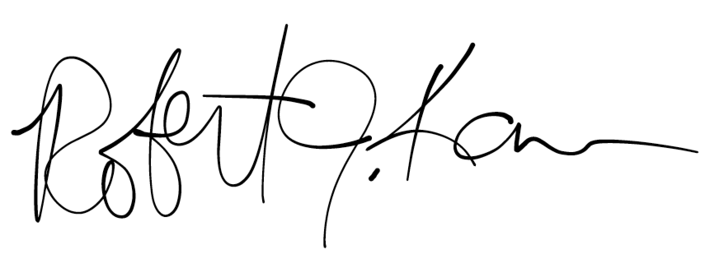

Faculty Member Signature Department Head Signature

Additional Comments:

